Question 3 – 4

For these questions, two different java programs were created. Compilation and running information can be found in README.txt file. All source codes and README file is supported in a cd.
Here are some screenshots of the program:

Strongly Connected Components & Bi-connected Components:
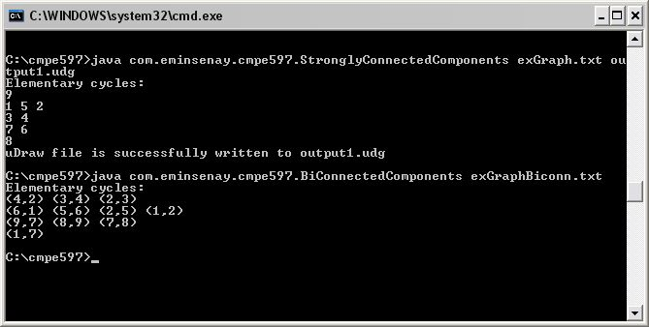

Output of Strongly Connected Components in uDraw(graph) file:

